Project Name
PC to PC Communication Using UART

Name: Rooshee Naktode
ID: UDN0Y642



Table of Contents
1.Introduction: 2
2.Scope: 3
3.Prerequisite: 3
3.1. Hardware: 3
3.2. Software: 3
4.Connection Diagram: 3
5.Working Principle: 3
6. Application code: 3
7. Hardware Setup Image: 3
8. Result: 3
9. Challenges Faced: 4
10. Appendix: 4
Revision History 4

1.Introduction:
The experiment PC to PC Communication Using UART demonstrates the fundamental concept of serial data communication between two computers using the UART (Universal Asynchronous Receiver/Transmitter) protocol. UART is a widely used hardware communication protocol that enables asynchronous data transfer between devices without the need for a shared clock signal.

In this setup, two computers are connected using USB-to-TTL UART converters, which act as an interface to convert USB signals into serial TTL-level signals. The communication is established by connecting the transmit (TX) pin of one converter to the receive (RX) pin of the other, along with a common ground (GND). Terminal software such as PuTTY or Tera Term is used on both computers to send and receive data.

The basic idea behind this experiment is to establish bidirectional (two-way) communication, where characters typed on one computer are transmitted through UART and displayed on the other computer in real time, and vice versa. This experiment helps in understanding serial communication principles, data transmission, and interfacing techniques, which are essential in embedded systems and microcontroller-based applications.

2.Scope:
The scope of this experiment is to implement and understand serial communication between two computers using the UART (Universal Asynchronous Receiver/Transmitter) protocol. The experiment focuses on establishing a reliable bidirectional data transfer system using USB-to-TTL UART converters and terminal software.
In this experiment, we will:
- Learn how to physically interface two systems using TX, RX, and GND connections
- Understand the working principle of asynchronous communication using UART
- Configure communication parameters such as baud rate, data bits, stop bits, and parity using tools like PuTTY or Tera Term
- Observe real-time transmission and reception of data between two PCs
- Verify correct communication by checking if the transmitted data from one system is accurately received on the other
This experiment helps students gain practical knowledge of serial communication protocols, debugging communication setups, and understanding how data exchange occurs in embedded and computer interfacing systems. It also builds a foundation for advanced applications such as microcontroller communication, IoT systems, and device interfacing.

3.Prerequisite:
Before performing this experiment, students should have a basic understanding of the following concepts:

Fundamentals of UART (Universal Asynchronous Receiver/Transmitter) communication, including TX, RX, and GND signals

Basic knowledge of serial communication parameters such as baud rate, data bits, stop bits, and parity

Familiarity with computer ports (COM ports) and how external devices interface with a PC

Basic operation of terminal software like PuTTY or Tera Term

Understanding of how to install drivers for USB-to-TTL converters (if required)

These prerequisites ensure that students can correctly set up the hardware connections and configure the communication parameters for successful UART data transmission.

3.1. Hardware:
The following hardware components are required to perform the experiment:

Two Desktop/Laptop Computers – Used as transmitting and receiving systems for UART communication

USB-to-TTL UART Converters (2 units) – Used to convert USB signals from the PC into TTL-level serial signals and vice versa (commonly based on chips like FT232RL or CP2102)

Jumper Wires – Used to connect TX, RX, and GND pins between the two converters

USB Cables – Used to connect the UART converters to the computers

Power Supply (via USB) – The converters are powered directly through the USB ports of the computers

These components together enable the physical setup required for establishing UART-based communication between two PCs

3.2. Software:
The following software tools are required to perform the experiment:

PuTTY / Tera Term – Terminal emulation software used to send and receive serial data between the two PCs

USB-to-TTL Converter Drivers – Drivers required for proper detection of the UART converter as a COM port (e.g., drivers for FT232RL or CP2102)

Operating System (Windows/Linux) – Provides the environment to run terminal software and manage COM ports

No programming language or IDE is required for this experiment, as communication is established directly using terminal software.

These software tools enable configuration, monitoring, and verification of UART communication between the two computers.

4.Connection Diagram:
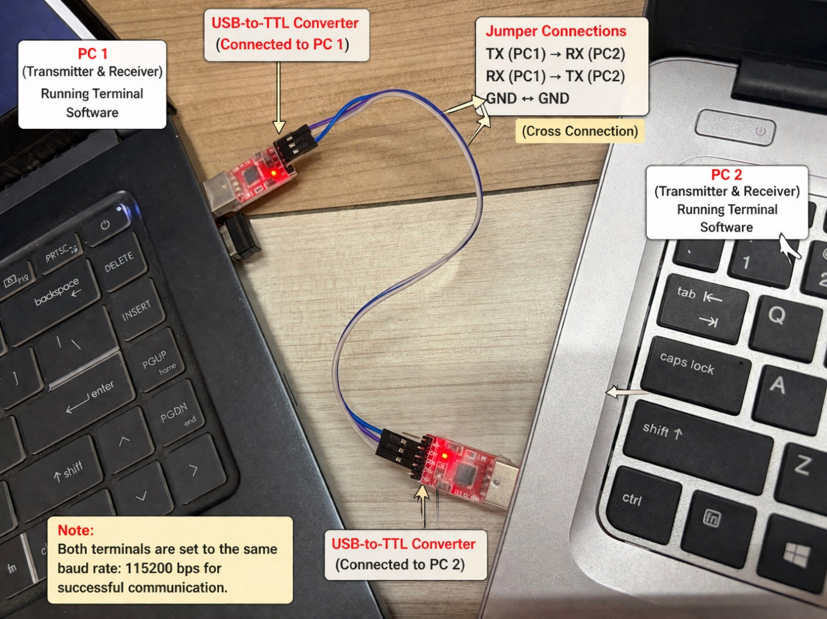

5.Working Principle:
The working principle of this experiment is based on asynchronous serial communication using the UART (Universal Asynchronous Receiver/Transmitter) protocol, where data is transmitted and received between two computers without a shared clock signal.

The step-by-step operation is as follows:

Initialization of Communication
Both computers are connected to their respective USB-to-TTL UART converters. Terminal software such as PuTTY or Tera Term is opened on both systems, and identical communication parameters (baud rate: 115200/9200 bps, data bits, stop bits, parity) are configured.

Signal Conversion
When a character is typed on one computer (PC1), it is sent through the terminal software to the USB port. The USB-to-TTL converter converts this USB data into TTL-level serial data suitable for UART communication.

Data Transmission (TX to RX)
The transmitted data from PC1 is sent through the TX (Transmit) pin of its converter. Due to cross-connection, this TX line is connected to the RX (Receive) pin of the second converter (PC2). A common GND ensures proper reference for signal transmission.

Data Reception and Display
The UART converter connected to PC2 receives the serial data through its RX pin and converts it back into USB format. The terminal software running on PC2 displays the received characters on the screen.

Bidirectional Communication
The same process occurs in reverse when data is typed on PC2. Thus, both computers can simultaneously transmit and receive data, enabling full-duplex communication.

Synchronization Without Clock
Since UART is asynchronous, both systems rely on pre-configured parameters (baud rate, start bit, stop bit) to synchronize data transmission and ensure accurate communication.

This experiment demonstrates how hardware (UART converters and connections) and software (terminal applications) work together to achieve reliable real-time data exchange between two systems.

6. Application code:
In this experiment, no embedded programming code is required because communication is established directly between two PCs using terminal software such as PuTTY or Tera Term.

Instead, the “application code” is replaced by the configuration settings and steps used to enable UART communication.

Terminal Configuration (PuTTY / Tera Term)

Open PuTTY / Tera Term on both PCs

Select Serial Communication mode

Choose the correct COM Port (e.g., COM3, COM4)

Set the following parameters on both systems:

Baud Rate: 115200/9200 bps

Data Bits: 8

Parity: None

Stop Bits: 1

Flow Control: None

Click Open to start the terminal session

Working (User Interaction)

Type any character on PC1, it will be transmitted and displayed on PC2

Similarly, typing on PC2 will display data on PC1

This confirms successful bidirectional UART communication

7. Hardware Setup Image:
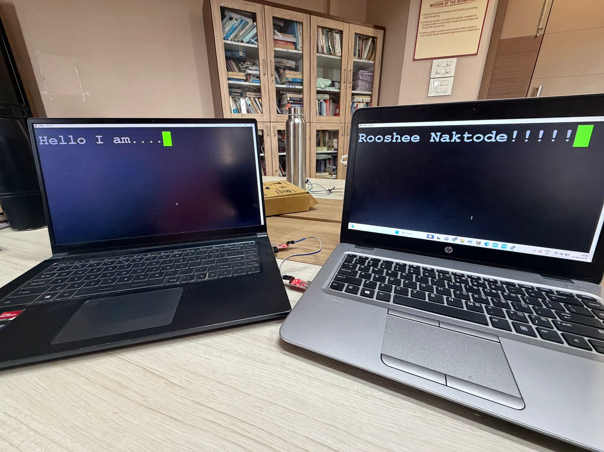

8. Result:
Observed Output (Evidence)

The experiment was successfully performed, and the output was verified using terminal software such as PuTTY / Tera Term on both PCs.

Characters typed on PC1 were displayed on PC2 in real-time

Characters typed on PC2 were displayed on PC1

Continuous two-way communication was observed without data loss

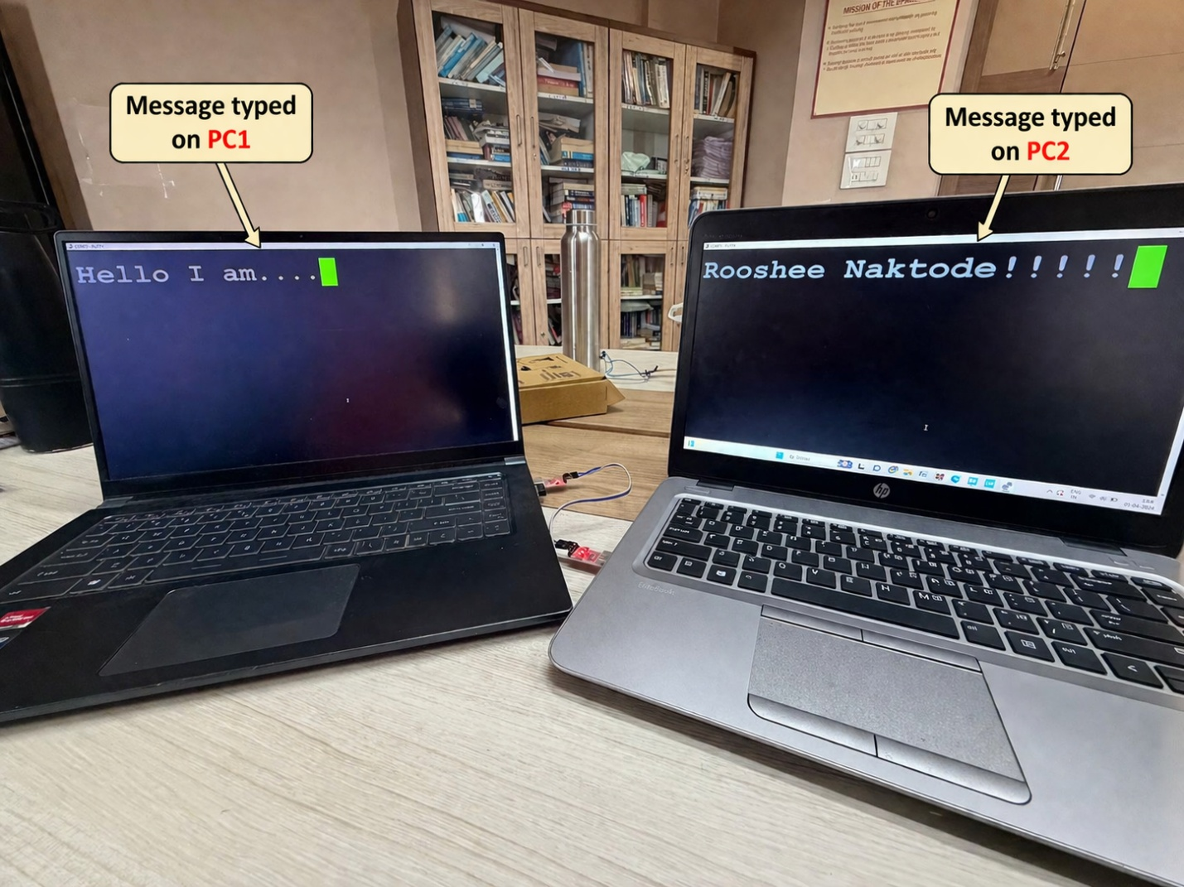
Conclusion of Result
The UART-based communication between two computers was successfully established using USB-to-TTL converters. The experiment confirmed that:
- Proper TX ↔ RX cross-connection enables data transfer
- Matching communication parameters (baud rate: 115200 bps) are essential
- Bidirectional (full-duplex) communication is achieved
Hence, the expected result was successfully obtained, demonstrating reliable UART communication between two PCs.

9. Challenges Faced:
- Incorrect cross-connection of TX and RX pins
- COM port not detected in system
- Baud rate mismatch between two PCs

10. Appendix:
The following references were used to understand and perform the experiment on PC-to-PC communication using UART:

- Official documentation on UART (Universal Asynchronous Receiver/Transmitter) – for understanding serial communication concepts and working principles
- User guides and tutorials of PuTTY – for configuring serial communication settings
- Datasheets of USB-to-TTL converters such as CP2102 and FT232RL
- Online electronics learning platforms and blogs explaining UART communication and serial interfacing

Revision History

Rev. No. | Date | Section | Change Description | Modified By

